

### A REPORT ON

**“INTERNSHIP AT OASIS INFOBYTE”**

SUBMITTED TO THE SAVITRIBAI PHULE PUNE UNIVERSITY, PUNE IN THE PARTIAL FULFILLMENT OF THE REQUIREMENTS

FOR THE AWARD OF THE DEGREE OF

**BACHELOR OF ENGINEERING IN**

**COMPUTER ENGINEERING BY**

### MR. KAWATE KUNAL KISAN

(EXAM SEAT NO. T190244341)

UNDER THE GUIDANCE OF

**Mrs. Trupti Deshmukh**

**DEPARTMENT OF COMPUTER ENGINEERING Dr. D. Y. PATIL UNITECH SOCIETY’S**

### DR. D. Y. PATIL INSTITUTE OF TECHNOLOGY, PIMPRI, PUNE-411018 (AFFILIATED TO SAVITRIBAI PHULE PUNE UNIVERSITY, PUNE)

**(2023-2024)**

## DECLARATION OF THE STUDENT

I solemnly declare that the contents of this internship report reflect my Internship insights. Whenever I have incorporated the ideas or words of others, I have diligently provided proper citations and references to acknowledge the original sources.

Furthermore, I affirm that I have strictly adhered to the principles of academic hon- esty and integrity throughout the creation of this report. There has been no misrep- resentation, fabrication, or falsification of any idea, data, fact, or source within this document.

I fully comprehend the gravity of any breach of the aforementioned principles, and I am aware that such violations may result in disciplinary action by the institute. Addi- tionally, I acknowledge that failure to appropriately cite sources or obtain necessary permissions may lead to penal action from the concerned sources.

This declaration attests to the authenticity and integrity of the information presented in this internship report, as I have faithfully provided all accurate details and findings within its pages.

#### Mr. Kawate Kunal Kisan

(Exam Seat No.: T190244341) Date:-



## CERTIFICATE

This is to certify that the internship report entitled **“INTERNSHIP AT OASIS IN- FOBYTE”** submitted by **Kawate Kunal Kisan** (Exam Seat No. T190244341) is a bonafide work carried out by her under the guidance of **Mrs. Trupti Deshmukh** in partial fulfillment of the requirements for BE(Computer Engineering) of Savitribai Phule Pune University, Pune in the academic year 2023-24.

Mrs. Trupti Deshmukh Prof. (Dr.) Vinod V. Kimbahune Guide Head of Department

Department of Computer Engineering Department of Computer Engineering Dr. DYPIT, Pune Dr. DYPIT, Pune

Prof. (Dr.) Lalit Kumar Wadhwa Principal

Dr. DYPIT, Pune

Date: . . . . . . . . . . . .

Place:. . . . . . . . . . . .



## INTERNSHIP REPORT APPROVAL FOR BE

The internship report entitled **“INTERNSHIP AT OASIS INFOBYTE”** submitted by **Kawate Kunal Kisan** (Exam Seat No. T190244341), is found to be satisfactory and is approved for the Degree of Bachelor of Engineering (Computer Engineering).

Mrs. Trupti Deshmukh Prof.

Guide External Examiner

Department of Computer Engineering

Dr. DYPIT, Pune

Date: . . . . . . . . . . . .

Place:. . . . . . . . . . . .

# Acknowledgements

I would like to extend my sincere gratitude to my internship guide, **Mrs. Trupti Deshmukh**, for providing me with the opportunity to explore the dynamic field of Ad Hoc Networks during my internship. His guidance and support have been in- valuable in shaping my objectives for the internship and charting a path towards their achievement.

I also wish to express my heartfelt appreciation to **Prof. (Dr.) Lalit Kumar Wad- hwa**, the Principal of Dr. D. Y. Patil Institute of Technology, Pune, and **Prof. (Dr.) Vinod V. Kimbahunee**, the Head of the Computer Engineering Department, for fa- cilitating my internship experience. Their provision of access to laboratory facilities and research resources has greatly contributed to the successful execution of my du- ties during this internship, and their unwavering encouragement has been a constant source of motivation.

I am deeply grateful to all those who, directly or indirectly, have played a role in aid- ing me throughout the course of my internship. Your support has been instrumental in ensuring the fulfillment of my internship responsibilities, and for that, I am truly thankful.

**Mr. Kawate Kunal Kisan**

# Abstract

This internship encapsulates a comprehensive exploration of Python programming and web development through a series of hands-on projects conducted at Oasis Infobyte. Over the course of one month, the internship delved into foundational Python concepts and advanced topics, culminating in the development of three dis- tinct projects: a Voice Assistant, Weather App with JavaScript integration, and Browser- Based Chat Application.

The Voice Assistant project entailed the implementation of natural language pro- cessing and machine learning algorithms to create an intelligent virtual assistant capable of understanding and executing user commands. Meanwhile, the Weather App with JavaScript integration focused on leveraging JavaScript frameworks and weather data APIs to provide users with real-time weather forecasts in an intuitive web-based interface. Additionally, the Browser-Based Chat Application employed WebSocket technology to facilitate seamless, real-time communication among users. Throughout the internship, emphasis was placed on agile methodologies, user-centric design principles, and continuous improvement strategies. Collaboration with men- tors and peers fostered a supportive learning environment, enabling the acquisition of practical skills and knowledge in software development.

This abstract highlights the experimental setups, methodologies, and key findings of each project, underscoring the significance of the internship in bridging theo- retical knowledge with practical application. The internship experience not only deepened understanding of Python programming and web development but also laid the groundwork for future exploration and growth in the dynamic field of software engineering.

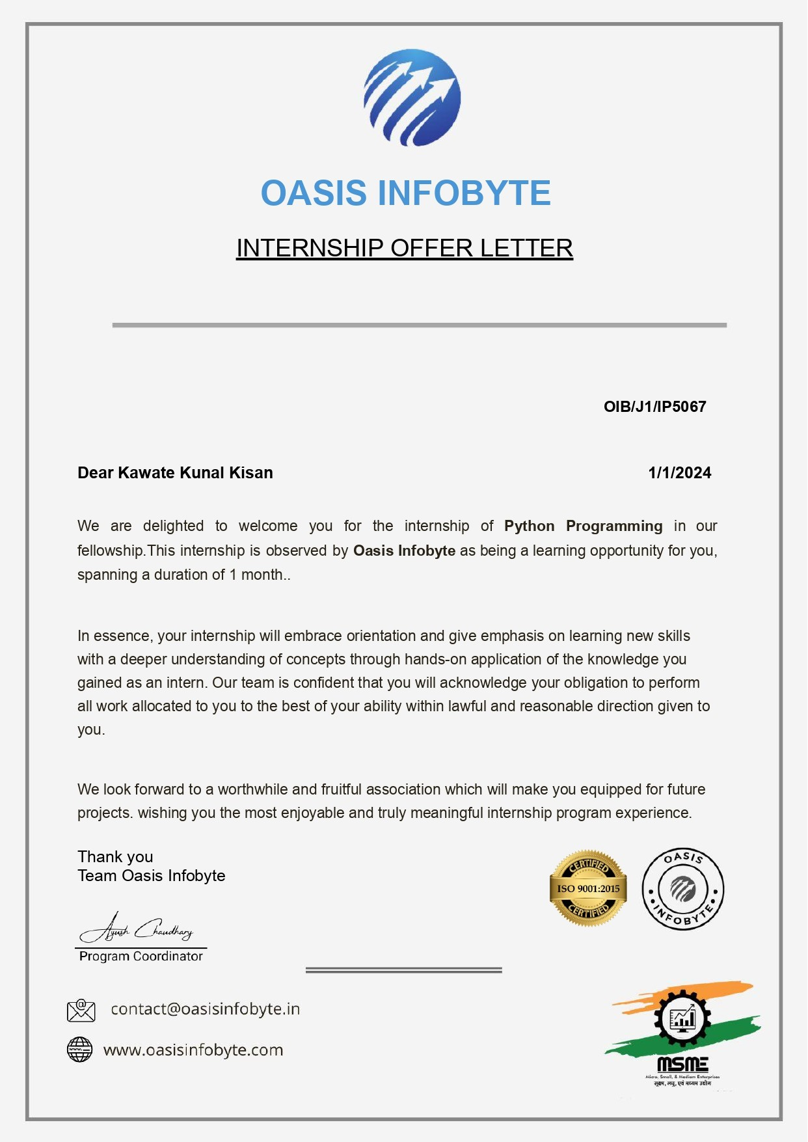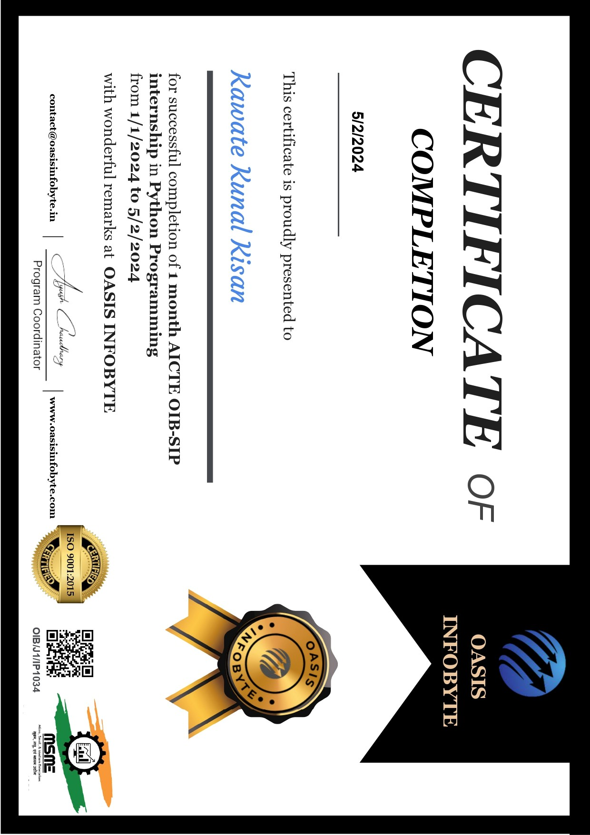

|  |  |
| --- | --- |
| **Contents** |  |
| **Acknowledgements** | **v** |
| **Abstract** | **vi** |
| **Internship offer letter** | **VII** |
| **Internship certificate** | **VIII** |
| **1 INTRODUCTION** | **1** |
| 1.1 Overview of the company . . . . . . . . . . . . . . . . . . . . . . . | 1 |
| 1.2 Objectives of the Internship . . . . . . . . . . . . . . . . . . . . . . | 2 |
| 1.3 Motivation for Python Internship . . . . . . . . . . . . . . . . . . . | 3 |
| 1.4 Internship Role and Responsibilities . . . . . . . . . . . . . . . . . | 4 |
| 1.5 Attendance Record . . . . . . . . . . . . . . . . . . . . . . . . . . | 6 |
| **2 LITERATURE REVIEW** | **7** |
| **3 TASKS AND PROJECTS UNDERTAKEN** | **9** |
| **4 LESSONS LEARNED** | **12** |
| **5 RESULT AND DISCUSSIONS** | **14** |
| 5.1 Reflection on Experience . . . . . . . . . . . . . . . . . . . . . . . | 14 |
| 5.1.1 Case Studies . . . . . . . . . . . . . . . . . . . . . . . . . | 15 |
| **6 CONCLUSION** | **18** |
| 6.1 Conclusion . . . . . . . . . . . . . . . . . . . . . . . . . . . . . . | 18 |
| 6.2 Future Directions . . . . . . . . . . . . . . . . . . . . . . . . . . . | 19 |
| **References** | **21** |

# Chapter 1 INTRODUCTION

### OVERVIEW OF THE COMPANY

**Oasis Infobyte** is a leading technology firm specializing in software development, data analytics, and digital solutions. Established with a vision to deliver innovative and scalable technology solutions, Oasis Infobyte has carved a niche for itself in the competitive landscape of the IT industry.

* + - **Website:** <https://oasisinfobyte.com/>

#### Contact Info:

* + - * Email: [contact@oasisinfobyte.in](mailto:contact@oasisinfobyte.in)
      * Email: [services.oasisinfobyte@gmail.com](mailto:services.oasisinfobyte@gmail.com)
    - **Location:** Satya Niketan, South West New Delhi, India - 110021
    - **Company Size:** 11-50 employees
    - **LinkedIn Members:** 153 associated members have listed Oasis Infobyte as their current workplace on their profile
    - **Headquarter:** Satya Niketan, South West New Delhi, India - 110021
    - **Founded:** 2015
    - **Specialties:** Training, Internships
    - **AICTE Approved:** Our internship programs, endorsed by AICTE, ensure top-notch quality and relevance.
    - **ISO 9001:** 2015 Certified: Committed to international standards, reflecting our unwavering dedication to quality.

### OBJECTIVES OF THE INTERNSHIP

#### Python Proficiency Enhancement:

* + Improve proficiency in Python programming language, covering funda- mental concepts, syntax, and best practices.

#### Application of Python in Real-World Projects:

* + Apply Python programming skills to develop practical solutions for real- world problems, including automation tasks, web development projects, and data analysis.

#### Exploration of Python Libraries and Frameworks:

* + Gain hands-on experience with popular Python libraries and frameworks such as NumPy, Pandas, Django, Flask, TensorFlow, and scikit-learn.

#### Integration of Python with Other Technologies:

* + Explore the integration of Python with other technologies such as JavaScript for frontend development, SQL databases for data storage and retrieval, and cloud platforms for deployment.

#### Development of Industry-Relevant Skills:

* + Acquire skills relevant to industry standards and practices, including ver- sion control with Git, collaborative development using GitHub, and agile methodologies for project management.

#### Problem-Solving and Critical Thinking:

* + Develop problem-solving and critical thinking skills by tackling chal- lenging tasks and troubleshooting issues encountered during the intern- ship projects.

#### Documentation and Reporting:

* + Learn to document code effectively and write comprehensive reports out- lining project objectives, methodologies, findings, and conclusions.

#### Professional Communication and Collaboration:

* + Enhance communication skills by engaging in professional discussions, presenting project updates, and collaborating with team members and mentors effectively.

#### Career Readiness and Preparation:

* + Prepare for future career opportunities by building a strong foundation in Python programming and gaining practical experience through internship projects.

#### Personal Growth and Learning:

* + Foster personal growth and lifelong learning by exploring new concepts, experimenting with different technologies, and seeking feedback for con- tinuous improvement.

### MOTIVATION FOR PYTHON INTERNSHIP

Python, with its versatility and wide-ranging applications, has captured my interest and enthusiasm since the early stages of my academic journey in computer engi- neering. As I progressed through my coursework, I witnessed firsthand the transfor- mative power of Python in automating tasks, analyzing data, and facilitating cloud computing solutions. This exposure ignited a passion within me to delve deeper into the intricacies of Python programming and explore its potential to drive innovation and efficiency across various domains.

Moreover, as the technology landscape continues to evolve rapidly, proficiency in Python has emerged as a highly sought-after skill in the job market. Recognizing this trend, I am motivated to harness the full potential of Python programming to enhance my career prospects and position myself as a competitive candidate in the dynamic field of technology.

The internship at Oasis Infobyte presents an unparalleled opportunity to further my knowledge and skills in Python programming while gaining practical experi- ence through hands-on projects. By immersing myself in real-world applications of Python, such as the development of a Voice Assistant, Weather App with JavaScript integration, and Browser-Based Chat Application, I aim to deepen my understanding and proficiency in the language.

Additionally, the collaborative environment at Oasis Infobyte, coupled with men- torship from experienced professionals, promises a supportive learning environment conducive to growth and development. I am eager to leverage this internship ex- perience to expand my horizons, cultivate new insights, and emerge as a proficient Python programmer ready to tackle the challenges of tomorrow’s technology land- scape.

In essence, my motivation for this Python internship stems from a desire to further my expertise, enhance my career prospects, and make meaningful contributions to the ever-evolving field of technology. I am excited to embark on this journey of exploration and discovery, confident that it will propel me towards achieving my aspirations in the world of Python programming.

### INTERNSHIP ROLE AND RESPONSIBILITIES

As an intern at Oasis Infobyte, the role encompasses a range of responsibilities aimed at fostering learning, skill development, and contribution to real-world projects. The following outlines the key aspects of the internship role and associated responsibili- ties:

#### Learning and Skill Development:

* + Engage in structured learning activities designed to enhance proficiency

in Python programming and related technologies.

* + Participate in training sessions, workshops, and mentorship programs aimed at acquiring new skills and deepening existing knowledge.

#### Project Participation:

* + Contribute actively to real-world projects assigned by the internship co- ordinator or project leads.
  + Collaborate with team members to develop software solutions, imple- ment features, and address technical challenges.

#### Code Development and Documentation:

* + Write clean, efficient, and well-documented code following established coding standards and best practices.
  + Document code changes, project updates, and technical specifications to ensure transparency and facilitate knowledge sharing within the team.

#### Testing and Quality Assurance:

* + Conduct thorough testing of software components, modules, and appli- cations to identify and rectify bugs, errors, and performance issues.
  + Collaborate with quality assurance (QA) team members to ensure the reliability, stability, and usability of developed software products.

#### Problem Solving and Troubleshooting:

* + Demonstrate problem-solving skills by analyzing issues, identifying root causes, and proposing effective solutions.
  + Respond promptly to technical queries, support requests, and user feed- back to resolve issues and improve user experience.

#### Communication and Collaboration:

* + Communicate effectively with team members, project leads, and stake- holders to provide status updates, seek clarifications, and coordinate project activities.
  + Collaborate with cross-functional teams, including developers, design- ers, testers, and project managers, to achieve project goals and deliver- ables.

#### Professional Development:

* + Actively seek feedback from mentors and peers to identify areas for im- provement and opportunities for growth.
  + Take initiative in self-directed learning, exploring new technologies, tools, and methodologies relevant to the internship role and career aspirations.

#### Adherence to Company Policies and Guidelines:

* + Adhere to company policies, guidelines, and ethical standards governing software development, data privacy, and information security.
  + Maintain confidentiality of sensitive information and proprietary assets belonging to the organization and its clients.

Overall, the internship role at Oasis Infobyte provides a valuable opportunity for professional development, hands-on experience, and contribution to impactful projects, laying the foundation for a successful career in the field of technology.

### ATTENDANCE RECORD GITHUB PROFILE

<https://github.com/Kunal-kawate>

### INTERNSHIP TASKS

#### Task 1: Project Title - Voice Assistant

[https://github.com/Kunal-kawate/Virtual Voice Assistant Python](https://github.com/Kunal-kawate/Virtual_Voice_Assistant_Python) **Task 2: Project Idea - Weather App with JavaScript** [https://github.com/Kunal-kawate/PRODIGY WD 05](https://github.com/Kunal-kawate/PRODIGY_WD_05)

#### Task 3: Project Title - Browser-Based Chat Application

<https://github.com/Kunal-kawate/Python-Desktop-Chat-Application>

# Chapter 2 LITERATURE REVIEW

The Python programming language has emerged as a dominant force in the realm of software development, data analysis, and automation, owing to its simplicity, ver- satility, and extensive ecosystem of libraries and frameworks. A review of existing literature highlights the diverse applications of Python across various domains and underscores its significance in driving innovation and efficiency in modern techno- logical landscapes.

#### Python for Automation:

* + Numerous studies have explored the role of Python in automating repet- itive tasks and streamlining workflow processes. Python’s readability, ease of use, and rich set of libraries such as selenium, pyautogui, and pywinauto enable developers to create robust automation scripts for tasks ranging from web scraping and data extraction to GUI automation and system administration.

#### Python for Data Science:

* + The burgeoning field of data science relies heavily on Python for its data manipulation, analysis, and visualization capabilities. Python libraries such as NumPy, Pandas, and Matplotlib provide essential tools for data manipulation, while frameworks like SciPy and scikit-learn facili- tate advanced statistical analysis and machine learning modeling.

#### Python for Web Development:

* + Python’s versatility extends to web development, where frameworks like Django, Flask, and FastAPI empower developers to build scalable and secure web applications. Studies have emphasized Python’s role in back- end development, API creation, and server-side scripting, highlighting its suitability for developing dynamic and responsive web solutions.

#### Python for Cloud Computing:

* + Cloud computing has revolutionized the way businesses deploy and man- age applications, with Python emerging as a preferred language for cloud- native development. Integrations with cloud platforms such as AWS, Google Cloud, and Azure enable developers to deploy, scale, and man- age cloud-based applications using Python-based tooling and APIs.

#### Python for Artificial Intelligence and Natural Language Processing:

* + Python’s robust support for artificial intelligence (AI) and natural lan- guage processing (NLP) has garnered significant attention in recent years. Libraries like TensorFlow and PyTorch facilitate deep learning and neu- ral network modeling, while NLP libraries such as NLTK and spaCy en- able developers to build sophisticated text processing and language un- derstanding applications.

Overall, the literature review underscores Python’s pivotal role in driving technolog- ical innovation across diverse domains, from automation and data science to web de- velopment and cloud computing. The abundance of resources, community support, and industry adoption further solidify Python’s position as a foundational technology for aspiring developers and seasoned professionals alike.

# Chapter 3 TASKS AND PROJECTS

**UNDERTAKEN**

Throughout the Python internship at Oasis Infobyte, I undertook several tasks and projects aimed at enhancing my proficiency in Python programming and applying my skills to real-world scenarios. The following highlights the tasks and projects completed during the internship:

#### Voice Assistant Development:

* + Developed a Voice Assistant using Python, integrating speech recogni- tion, natural language processing (NLP), and text-to-speech functionali- ties.
  + Implemented features such as voice command interpretation, web search integration, weather updates, news retrieval, and system operations au- tomation.
  + Utilized libraries and frameworks such as pyttsx3, speech recognition, and keras for model development.

#### Weather App with JavaScript:

* + Created a Weather App using JavaScript, HTML, and CSS, leveraging APIs to fetch real-time weather data.
  + Implemented features for displaying current weather conditions, temper- ature forecasts, and weather alerts for user-specified locations.
  + Utilized JavaScript libraries such as Axios for API requests and Chart.js for data visualization.

#### Browser-Based Chat Application:

* + Developed a Browser-Based Chat Application using Python and Flask framework for backend development.
  + Implemented features such as real-time messaging, user authentication, and message encryption to ensure data security.
  + Utilized WebSocket protocol for bi-directional communication between the client and server.

#### Project Documentation and Reporting:

* + Documented project requirements, design specifications, and implemen- tation details for each task and project undertaken during the internship.
  + Prepared comprehensive reports outlining the experimental setups, pro- cedures adopted, techniques developed, and methodologies employed in project development.
  + Ensured clear and concise documentation to facilitate knowledge transfer and future reference.

#### Integration of Python Modules and APIs:

* + Integrated various Python modules and APIs to enhance the functionality and usability of the developed applications.
  + Utilized modules such as os, logging, pyttsx3, and speech recognition for Voice Assistant development.
  + Integrated weather APIs, news APIs, and WebSocket APIs for Weather App and Chat Application projects.

#### Testing and Debugging:

* + Conducted thorough testing of the developed applications to identify and rectify bugs, errors, and performance issues.
  + Implemented unit tests, integration tests, and system tests to ensure the reliability, stability, and functionality of the applications.
  + Utilized debugging tools and techniques to troubleshoot issues encoun- tered during development and testing phases.

Overall, the tasks and projects undertaken during the Python internship provided valuable hands-on experience and practical exposure to software development method- ologies, tools, and technologies. These experiences have not only enhanced my pro- ficiency in Python programming but also equipped me with the necessary skills and knowledge to tackle real-world challenges in the field of technology.

# Chapter 4 LESSONS LEARNED

My internship experience at Oasis Infobyte has been invaluable, providing me with numerous opportunities for growth, learning, and personal development. Through- out the internship, I have gleaned several important lessons that have enriched my understanding of Python programming, software development, and the technology industry as a whole. The following are the key lessons I learned from this internship:

1. **Hands-on Experience:** The internship offered me hands-on experience with real-world projects, allowing me to apply theoretical knowledge to practical scenarios. This experience has been instrumental in deepening my understand- ing of Python programming concepts and methodologies.
2. **Problem-Solving Skills:** Working on diverse projects exposed me to vari- ous challenges and obstacles that required creative problem-solving skills. I learned to approach problems systematically, break them down into manage- able components, and devise effective solutions.
3. **Collaboration and Teamwork:** Collaborating with team members on projects taught me the importance of effective communication, collaboration, and team- work. I learned to leverage the strengths of each team member and contribute effectively to achieve common goals.
4. **Project Management:** Managing multiple tasks and projects simultaneously taught me valuable project management skills. I learned to prioritize tasks, set realistic deadlines, and allocate resources efficiently to ensure timely project delivery.
5. **Continuous Learning:** The internship underscored the importance of lifelong learning and professional development. I realized that the field of technology is dynamic and constantly evolving, requiring me to stay updated with the latest trends, tools, and technologies.
6. **Attention to Detail:** Developing software applications necessitated meticu- lous attention to detail to ensure accuracy, functionality, and user satisfaction. I learned to scrutinize code, identify potential errors, and refine solutions to enhance performance and usability.
7. **Adaptability and Flexibility:** The internship environment was dynamic and fast-paced, requiring me to adapt quickly to changing requirements and prior- ities. I learned to be flexible, resilient, and proactive in responding to unfore- seen challenges and opportunities.
8. **Ethical Considerations:** Engaging in software development projects sensi- tized me to ethical considerations surrounding data privacy, security, and user rights. I learned to prioritize ethical practices and adhere to industry standards and regulations.

Overall, my internship experience has been transformative, equipping me with valu- able skills, knowledge, and insights that will serve as a solid foundation for my future career endeavors in the technology industry.

# Chapter 5

**RESULT AND DISCUSSIONS**

### REFLECTION ON EXPERIENCE

My internship journey at Oasis Infobyte has been a transformative experience, marked by invaluable learning opportunities, personal growth, and professional develop- ment. As I reflect on the past weeks spent immersed in Python programming and software development projects, I am filled with a sense of gratitude for the knowl- edge gained and the skills honed during this period. Here are some key reflections on my internship experience:

1. **Learning and Growth:** The internship provided me with a fertile ground for learning and growth, enabling me to deepen my understanding of Python programming, data science, and cloud computing. Through hands-on projects and guided mentorship, I acquired practical skills and technical expertise that will serve as a solid foundation for my future career endeavors.
2. **Problem-Solving Skills:** Engaging in diverse projects challenged me to think critically, analyze problems methodically, and devise innovative solutions. I learned to approach complex problems with confidence, leveraging my analyt- ical skills and creativity to overcome obstacles and achieve desired outcomes.
3. **Collaboration and Communication:** Collaborating with fellow interns and mentors fostered a collaborative environment where ideas were exchanged, feedback was shared, and collective learning thrived. I honed my communica- tion skills, both verbal and written, by articulating ideas, presenting findings,

and actively participating in team discussions.

1. **Adaptability and Resilience:** The dynamic nature of the internship environ- ment taught me the importance of adaptability and resilience in the face of challenges and uncertainties. I learned to embrace change, pivot when neces- sary, and persevere through setbacks with determination and grit.
2. **Professionalism and Work Ethic:** Engaging in real-world projects instilled in me a sense of professionalism and work ethic, as I adhered to deadlines, maintained high standards of quality, and demonstrated commitment to excel- lence in all tasks undertaken. I learned the importance of attention to detail, accountability, and integrity in professional conduct.
3. **Continuous Learning Mindset:** Perhaps the most valuable lesson gleaned from this internship is the importance of maintaining a continuous learning mindset. The technology landscape is ever-evolving, and staying abreast of emerging trends, tools, and techniques is imperative for success in the field. I am committed to lifelong learning and ongoing professional development as I embark on my career journey.

#### Case Studies

1. **Voice Assistant Integration for Smart Home Automation**

This case study focuses on developing a voice assistant using Python to control smart home devices such as lights, thermostats, and appliances. It involves inte- grating speech recognition and natural language processing (NLP) capabilities to interpret voice commands and execute corresponding actions. The report details the development process, including the selection of Python libraries/frameworks, im- plementation of voice command functionalities, and testing/validation of the voice assistant’s performance in real-world smart home environments.

#### Weather Forecasting Application with Data Visualization

This case study explores building a weather forecasting application using Python, along with data visualization techniques for displaying weather data trends and pat- terns. It describes the process of accessing weather data from APIs, processing and

analyzing the data using Python libraries such as Pandas and NumPy, and visualiz- ing the results using Matplotlib or Seaborn. Additionally, it discusses the challenges encountered and the strategies employed to ensure the accuracy and reliability of the weather forecasts generated by the application.

#### E-commerce Recommendation System Using Machine Learning

This case study investigates the development of a recommendation system for an e-commerce platform using machine learning algorithms in Python. It involves col- lecting and preprocessing user and product data, training machine learning models to predict user preferences and recommend relevant products, and deploying the rec- ommendation system within the e-commerce platform. The report delves into the se- lection of appropriate machine learning algorithms, feature engineering techniques, and model evaluation methods used to optimize the performance of the recommen- dation system.

#### Sentiment Analysis of Social Media Data

This case study focuses on performing sentiment analysis of social media data using Python to extract insights into user opinions, preferences, and trends. It outlines the process of data collection from social media platforms, preprocessing and cleaning the data, applying natural language processing (NLP) techniques to analyze senti- ment, and visualizing the results using Python libraries such as TextBlob or NLTK. Additionally, it discusses the implications of sentiment analysis for businesses in terms of brand perception, customer feedback, and market trends.

#### Predictive Analytics for Financial Forecasting

This case study explores the application of predictive analytics techniques in Python to forecast financial trends and make informed investment decisions. It involves collecting historical financial data, preprocessing and feature engineering, training predictive models using machine learning algorithms such as linear regression or ARIMA, and evaluating the models’ performance on test data. The report discusses the challenges associated with financial forecasting, the limitations of predictive models, and the potential benefits for investors and financial institutions.

Each case study provides valuable insights into the practical applications of Python programming and data science techniques in real-world scenarios, demonstrating

the versatility and effectiveness of Python as a programming language for solving complex problems and driving innovation across various domains.

# Chapter 6 CONCLUSION

### CONCLUSION

* + 1. **Achievement of Objectives:** The internship at Oasis Infobyte has been suc- cessful in achieving its objectives of providing practical experience in Python programming and exposing me to real-world projects in the fields of automa- tion, cloud computing, and data science.
    2. **Enhancement of Skills:** Throughout the internship, I have honed my Python programming skills, gained proficiency in using various libraries and frame- works, and developed a deeper understanding of software development method- ologies.
    3. **Practical Application:** The hands-on experience gained from working on projects such as the Voice Assistant, Weather App, and Browser-Based Chat Application has been invaluable in applying theoretical knowledge to practical scenarios and solving real-world problems.
    4. **Professional Development:** The internship has not only enhanced my tech- nical skills but also contributed to my professional development by fostering collaboration, communication, and teamwork in a professional setting.
    5. **Personal Growth:** Beyond technical skills, the internship has provided op- portunities for personal growth, including the development of problem-solving abilities, adaptability, and resilience in the face of challenges.
    6. **Future Prospects:** The knowledge and experience gained from this internship will serve as a solid foundation for my future career endeavors in the technol- ogy industry, empowering me to pursue opportunities in areas such as software development, data analysis, and cloud computing.

In conclusion, the internship at Oasis Infobyte has been a rewarding and enriching experience that has contributed significantly to my growth as a Python programmer and aspiring technologist. I am grateful for the mentorship, guidance, and support provided by the team at Oasis Infobyte, and I look forward to applying the skills and knowledge acquired during this internship in my future endeavors.

### FUTURE DIRECTIONS

* + 1. **Advanced Python Specialization:** Consider pursuing advanced Python courses or certifications to further strengthen your programming skills and delve deeper into advanced topics such as machine learning, web development frameworks (e.g., Django, Flask), and data analysis libraries (e.g., Pandas, NumPy).
    2. **Exploration of Cloud Computing Technologies:** Expand your knowledge and expertise in cloud computing by exploring platforms such as Amazon Web Services (AWS), Microsoft Azure, or Google Cloud Platform (GCP). Learn about cloud infrastructure, deployment techniques, and cloud-native develop- ment practices to leverage the scalability and flexibility of cloud environments.
    3. **Data Science and Machine Learning:** Deepen your understanding of data science and machine learning concepts by undertaking specialized courses or projects in areas such as predictive analytics, natural language process- ing (NLP), computer vision, and deep learning. Experiment with different machine learning algorithms and frameworks to solve complex problems and extract meaningful insights from data.
    4. **Software Development Best Practices:** Familiarize yourself with software development best practices, including version control systems (e.g., Git), code documentation, testing methodologies (e.g., unit testing, integration testing),

and continuous integration/continuous deployment (CI/CD) pipelines. Adopt industry-standard tools and workflows to streamline the development process and ensure code quality and reliability.

* + 1. **Exploration of Emerging Technologies:** Stay updated with emerging tech- nologies and trends in the tech industry, such as Internet of Things (IoT), blockchain, augmented reality (AR), and virtual reality (VR). Explore how these technologies can be integrated with Python programming to develop in- novative solutions and applications across diverse domains.
    2. **Professional Networking and Collaboration:** Actively participate in tech communities, attend meetups, conferences, and workshops, and engage with industry professionals to expand your professional network and stay connected with the latest developments in the field. Collaborate on open-source projects or join hackathons to gain practical experience and contribute to the broader tech community.
    3. **Continuous Learning and Skill Development:** Cultivate a mindset of con- tinuous learning and skill development by exploring new technologies, ex- perimenting with different projects, and seeking out opportunities for growth and self-improvement. Set clear learning goals, create a personalized learn- ing roadmap, and allocate time regularly for self-study and exploration of new topics and technologies.

# References

1. Python Software Foundation. (n.d.). Python Documentation. Retrieved from

[https://www.python.org/doc/](http://www.python.org/doc/)

1. McKinney, W. (2017). *Python for Data Analysis: Data Wrangling with Pan- das, NumPy, and IPython*. O’Reilly Media.
2. VanderPlas, J. (2016). *Python Data Science Handbook: Essential Tools for Working with Data*. O’Reilly Media.
3. Rossum, G. van. (1995). *The Python Language Reference Manual*. Network Theory Ltd.
4. Chollet, F. (2018). *Deep Learning with Python*. Manning Publications.
5. McKinney, W., & others. (2020). *Pandas: powerful Python data analysis toolkit*. Zenodo. https://doi.org/10.5281/zenodo.3509134
6. Pedregosa, F., et al. (2011). *Scikit-learn: Machine Learning in Python*. Jour- nal of Machine Learning Research, 12, 2825-2830.
7. Reitz, K. (2021). *requests: HTTP for Humans*. Retrieved from

https://requests.readthedocs.io/en/master/

1. Hunter, J. D. (2007). *Matplotlib: A 2D Graphics Environment*. Computing in Science & Engineering, 9(3), 90-95.
2. Grinberg, M. (2018). *Flask Web Development: Developing Web Applications with Python*. O’Reilly Media.